

YouTube Insights Analysis

Designed and Developed by
- P. Ganesh 2211CS010455

- P. Pavan 2211CS010449

- P. Saketh 2211CS010474

- Shaik Fathima 2211CS010528

Guided by
Mrs. P. Shilpa

Department of Computer Science & Engineering
MALLAREDDYUNIVERSITY, HYDERABAD

2024-2025

I



CERTIFICATE

This is to certify that this is the Application development lab record entitled “YouTube Insights Analysis” submitted by P.Ganesh (2211CS010455), P.Pavan (2211CS010449), P. Saketh(2211CS010474), Shaik Fathima(2211CS010528) B.Tech III year II semester, Department of CSE during the year 2024-25. The results embodied in this report have not been submitted to any other university or institute for the award of any degree or diploma.

Internal Guide DEAN-CSE
Mrs. P.Shilpa Dr. Shaik Meeravali

External Examiner

II

DECLARATION

I declare that this project report titled “YouTube Insights Analysis” submitted in partial fulfillment of the degree of B. Tech in CSE is a record of original work carried out by me under the supervision of Mrs. P. Shilpa, and has not formed the basis for the award of any other degree or diploma, in this or any other Institution or University. In keeping with the ethical practice in reporting scientific information, due acknowledgements have been made wherever the findings of others have been cited.

- P. Ganesh 2211CS010455
- P. Pavan 2211CS010449
- P. Saketh 2211CS010474
- Shaik Fathima 2211CS010528

III

ACKNOWLEDGEMENT

With great pleasure we want to take this opportunity to express our heartfelt gratitude to all the people who helped in making this mini project a grand success. We express our deep sense of gratitude to Mrs. P. Shilpa for his constant guidance throughout our mini project work. First of all, we express our sincere thanks to the Chairman for this continuous care towards our achievements. We are highly indebted to the Vice Chancellor, for giving us the permission to carry out this mini project. We would like to thank Dr. Shaik Meeravali, Dean of the Department of Computer Science and Engineering, for providing seamless support and right Suggestions in the development of the project. Last but not the least we would like to thank the Teaching & Non-Teaching staff of CSE Department for sharing their knowledge with us.

- P. Ganesh 2211CS010455

- P. Pavan 2211CS010449

- P. Saketh 2211CS010474

- Shaik Fathima 2211CS010528

IV

ABSTRACT

The YouTube Insights Analysis project is a comprehensive tool designed to empower YouTube content creators and marketers with actionable insights into video performance, audience sentiment, and engagement metrics. By leveraging the YouTube Data API, the platform collects real-time data on videos and comments, enabling dynamic analysis of key metrics such as views, likes, comments, and engagement rates. The project integrates sentiment analysis to classify comments as positive, negative, or neutral, word cloud generation to visualize frequently used words, and emoji analysis to identify popular emojis in comments. This project provides Video performance analysis where it Analyzes metrics like views, likes, comments, and engagement rates.
Additionally, the platform employs machine learning models (RandomForestRegressor) to predict engagement metrics (likes and comments) for new videos based on features such as expected views, title length, and title sentiment. Built using Streamlit, the project provides an interactive and user-friendly interface that allows users to explore insights, analyze trends, and optimize their content strategy.

V

TABLE OF CONTENT

DESCRIPTION PAGE
 | NUMBER
CERTIFICATE | ii
DECLARATION | iii
ACKNOWLEDGMENT | iV
ABSTRACT | V
Chapter 1 Introduction | 1-4
1.1 Introduction | 1
1.2 Problem Statement | 2
1.3 Objective | 2-4
1.4 Goal | 4
Chapter 2 Problem Identification | 5-7
2.1 Existing System | 5
2.2 Proposed System | 6-7
Chapter 3 Requirements | 8-9
3.1 Software Requirements | 8-9
3.2 Hardware Requirements | 9
Chapter 4 Design andImplementation | 10-12
4.1 Design | 10-11
4.2 Implementation | 11-12
Chapter 5 Code | 13-28
5.1 Source code | 13-23
5.2 Screenshots of Application | 23-28
Chapter 6 Results and Conclusion | 29-33
6.1 Results | 29-30
6.2 Conclusion | 30-32
REFERENCES | 33

VI

LIST OF FIGURES

FIGURE | TITLE | PAGE NUMBER
4.1.1 | Use Case Diagram | 12
4.1.2 | Sequence Diagram | 13
4.1.3 | Class Diagram | 14
4.1.4 | Activity Diagram | 15
5.2.1 | Upload and Overview | 16
5.2.2 | Comments analysis | 35
5.2.3 | Sentiment types | 35
5.2.4 | Positive sentiment | 36
5.2.5 | Negative sentiment | 36
5.2.6 | Emoji frequency analysis | 37
5.2.7 | Performance analysis | 38
5.2.8 | Prediction management  VII | 39

CHAPTER – 1

INTRODUCTION

1.1 Introduction
The YouTube Insights Analysis project is designed to provide a comprehensive tool for analyzing real-time YouTube data, including video performance metrics, audience sentiment from comments, and predictive analytics for engagement metrics such as likes and comments.
This project leverages the YouTube Data API to collect real-time data, Streamlit for building an interactive web application, and advanced analytics techniques such as sentiment analysis, word cloud generation, and machine learning models for engagement prediction. The goal is to empower content creators and marketers with actionable insights to enhance their YouTube strategies.
The sentiment analysis component of YouTube Insights Analysis is powered by TextBlob, which classifies comments as positive, negative, or neutral based on sentiment polarity. This enables content creators to understand audience perception and tailor their content accordingly. Additionally, the platform provides word cloud and emoji analysis, visualizing frequently used words and emojis in comments to identify audience preferences and trends.
The video performance analysis component evaluates key metrics such as views, likes, comments, and engagement rates, offering insights into how videos are performing. The platform also features an engagement prediction model, which utilizes machine learning (RandomForestRegressor) to predict likes and comments for new videos based on factors like expected views, title length, and sentiment score. This predictive capability helps content creators strategize their content and optimize future videos.

Problem Statement

With millions of videos uploaded daily, YouTube has become a crucial platform for content creator’s marketers, and businesses. However, understanding audience engagement, video performance, and sentiment analysis remains a challenge. Content creators often struggle to extract meaningful insights from video metrics, audience feedback, and engagement trends, leading to suboptimal content strategies and reduced viewer retention.

This project aims to address these challenges by developing an interactive web-based analytics tool that collects real-time YouTube video data using the YouTube Data API. The system will analyze key performance metrics such as views, likes, comments, and watch time, while also leveraging sentiment analysis and machine learning techniques to predict engagement trends. Additionally, features like word cloud generation will provide deeper insights into audience sentiment.

By offering a comprehensive and user-friendly analytics solution, this project empowers content creators and marketers with actionable insights to enhance their YouTube strategies.

Objective of the project

The YouTube Insights Analysis Project aims to help content creators, marketers, and businesses understand video performance, audience engagement, and sentiment analysis using real-time data. By leveraging the YouTube Data API, machine learning, and NLP techniques, this project provides actionable insights to optimize content strategies and enhance viewer interaction. Below are the key objectives of the project:

1. Data Collection

YouTube Data API: The project leverages the YouTube Data API to collect real-time data on videos and comments. This includes:

Video Metadata: Title, Channel, Published date, Views, Likes, Comments.

Comments: Video_ID, Author, Comments, Likes, Replies.

2. Data Preprocessing

HTML Cleaning: Comments are cleaned using BeautifulSoup to remove HTML tags while preserving YouTube links for readability.

Missing Data Handling: Rows with missing comments are removed to ensure data quality.

Sentiment Score Calculation: Each cleaned comment is analyzed using TextBlob to calculate sentiment polarity for further classification into positive, negative, or neutral.

Emoji Handling: Emojis are retained in the text and later extracted for separate frequency analysis.

3. Sentiment Analysis

TextBlob: Use TextBlob to classify comments as positive, negative, or neutral based on sentiment polarity.

Histograms: Show the distribution of sentiment scores.

Tables: Display top positive, negative, and neutral comments.

4. Word Cloud and Emoji Analysis
Word Cloud: Generate a word cloud to visualize the most frequently used words in comments. Emoji Analysis: Identify and visualize the most frequently used emojis in comments.

5. Video Performance Analysis
Scatter Plots: Visualize relationships between metrics (e.g., views vs. likes, views vs. comments). Heatmaps: Show correlations between metrics (e.g., views, likes, comments).
Engagement Rate Distribution: Use histograms to display the distribution of engagement rates across videos.
Top Engaging Videos: Identify the top 10 videos with the highest engagement rates.

6. Engagement Prediction

Machine Learning Models: Use RandomForestRegressor to predict likes and comments for new videos.

Features: Views, title length, and sentiment score.

Training: Split the dataset into training and testing sets.Train the model on the training set and evaluate its performance on the testing set.

Prediction: Predict likes and comments for new videos based on expected views, title length, and sentiment score.

7. Interactive Visualization

Streamlit: Build an interactive and user-friendly interface using Streamlit.

Features: Upload data and explore insights.

1.4 Goal of the project
The primary goal of this project is to develop a comprehensive analytics system that enables content creators, marketers, and businesses to gain deep insights into YouTube video performance and audience engagement. By leveraging the YouTube Data API, sentiment analysis, and machine learning techniques, the project aims to provide real-time data analysis, helping users understand key performance metrics such as views, likes, comments, and audience sentiment. This will allow creators to optimize their content strategies, enhance viewer engagement, and improve overall video performance.
Another goal is to implement predictive analytics to forecast engagement trends based on historical data, enabling content creators to anticipate audience reactions and adjust their content accordingly. By using machine learning models, the system will predict likes, comments, and other engagement factors, offering actionable insights for better decision-making. Additionally, features like word cloud generation will help identify trending topics and audience interests, allowing creators to tailor their content to viewer preferences.
The project also aims to provide an interactive, user-friendly platform using Streamlit, making advanced analytics accessible to users with minimal technical expertise. This ensures that content creators and marketers can easily navigate the system, track performance trends, and gain meaningful insights without requiring extensive data analysis skills. By integrating a well-structured and scalable solution, the project ensures adaptability for different types of content creators and marketing strategies.
Ultimately, the goal is to empower users with data-driven insights to enhance their content strategies, maximize audience engagement, and improve YouTube channel performance. By transforming raw data into actionable intelligence, this project highlights the potential of data analytics and machine learning in revolutionizing digital content strategies and audience engagement in the ever-evolving YouTube ecosystem.

CHAPTER – 2
PROBLEM IDENTIFICATION

2.1 Existing System

In the field of sentiment analysis for YouTube comments, existing systems often utilize tools like VADER(Valence Aware Dictionary and Sentiment Reasoner), a rule-based approach designed for social media text. While VADER is effective for analyzing short and informal content, it struggles with capturing complex language nuances and contextual sentiment, limiting its accuracy in deeper analysis.

For engagement prediction, traditional methods like Linear Regression are commonly used to estimate metrics such as likes and comments based on video metadata, including views and title length. However, its simplistic approach fails to capture the intricate, non-linear relationships that influence real-world engagement patterns.

When it comes to comment analysis, conventional methods rely on manual tagging, where human annotators classify comments as positive, negative, or neutral. This process is time-consuming, lacks scalability, and is prone to inconsistencies. Additionally, keyword filtering techniques are employed to detect spam or offensive content, but they often fall short due to their inability to understand context, leading to low accuracy.

Basic video performance analysis typically relies on static correlation techniques like Pearson correlation to measure relationships between engagement metrics such as views and likes. However, these methods assume linear dependencies, making them ineffective in capturing complex, dynamic patterns in user engagement data.

These limitations highlight the need for more advanced, accurate, and scalable solutions. YouTube Insights Analysis addresses these challenges by integrating sentiment analysis, machine learning, and interactive visualization to provide deeper, real-time insights into audience engagement and content performance.

Proposed System

The YouTube Insights Analysis project is a comprehensive, AI-driven platform designed to empower content creators and marketers with deep, data-driven insights into video performance, audience sentiment, and engagement metrics. By leveraging the YouTube Data API, the system collects real-time data on videos and user comments, enabling dynamic tracking of key performance indicators such as views, likes, comments, and engagement rates.

Advanced Sentiment Analysis
The system employs natural language processing (NLP) techniques to automatically classify comments into positive, negative, or neutral categories. Additionally, it generates word clouds to visualize frequently used terms and performs emoji analysis to detect sentiment trends based on commonly used emojis. Unlike traditional sentiment analysis tools, this system accounts for context and sarcasm detection, making sentiment classification more accurate and insightful.

Enhanced Video Performance Analysis
Beyond basic engagement tracking, the platform examines complex relationships between key metrics such as views, likes, comments, and shares to identify audience behavior patterns. It integrates time-series analysis to track performance fluctuations over time, helping creators understand seasonal trends and the impact of external factors such as trending topics and video release timings.

Machine Learning-Powered Engagement Predictions
To further optimize content strategies, the platform utilizes advanced machine learning models, particularly the random forest regressor, to predict engagement metrics such as likes and comments for upcoming videos. These predictions are based on a range of input features, including expected views, video title length, video duration, posting time, keyword density, and title sentiment score. This predictive capability allows content creators to fine-tune their content strategies before publishing.

Interactive Visualization & User-Friendly Experience
The entire system is built using Streamlit, offering an intuitive and interactive interface that allows users to:
✔ Upload video data and analyze real-time insights
✔ Explore audience engagement through dynamic visualizations
✔ Generate predictive insights to optimize future content
✔ Filter and categorize comments based on sentiment and engagement level

Competitive Edge & Strategic Decision-Making
Unlike conventional analytics tools that provide static insights, YouTube Insights Analysis offers a real-time, AI-powered solution that helps content creators make data-backed decisions. By combining sentiment analysis, engagement prediction, and visual analytics.

CHAPTER – 3
REQUIREMENTS

3.1 Software Requirements
1. Programming Languages
Python – Used for data processing, visualization, machine learning, and backend operations.

2. Development Environment
Jupyter Notebook / Google Colab – For model training and experimentation.
Visual Studio Code (VS Code) / PyCharm – For developing and running the Streamlit web application.

3. Libraries and Frameworks
Frontend & Web App Development
Streamlit – For building an interactive web application.
Streamlit - option-menu – To add navigation features in the Streamlit app.

Data Handling & Processing
Pandas – For reading, handling, and processing CSV datasets.
BeautifulSoup – For cleaning HTML content in YouTube comments.

Data Visualization
Matplotlib – For generating plots and static visualizations.
Seaborn – For statistical and correlation heatmap visualizations.
Plotly (plotly.express, plotly.graph_objects) – For interactive visualizations.
WordCloud – For creating word clouds from YouTube comments.

Natural Language Processing (NLP)
TextBlob – For performing sentiment analysis on comments.
Emoji (emoji library) – To extract and analyze emoji usage in comments.
Collections (Counter) – To count and analyze word/emoji frequency.
Machine Learning & Model Development

Scikit-Learn (sklearn) – For training and using machine learning models.
Joblib – For saving and loading trained models.
NumPy – For numerical computations.

4. Deployment & Hosting
Streamlit Cloud / Heroku / AWS / Google Cloud – For deploying the web-based application.

5. Additional Tools
Git & GitHub – For version control and project collaboration.
Postman – For testing API endpoints (if APIs are integrated).
Requests – To fetch external images and resources from URLs.
Requests – To fetch external images and resources from URLs.

3.2 Hardware Requirements

Minimum Hardware Requirements (For Basic Development & Small Datasets)

Processor: Intel Core i3 (8th Gen) or AMD Ryzen 3
RAM: 8 GB
Storage: 256 GB SSD or 500 GB HDD
GPU: Integrated Graphics (sufficient for basic ML models)
Operating System: Windows 10/11, macOS, or Linux (Ubuntu recommended)
Internet Connection: Required for downloading dependencies, cloud deployment, and dataset access.

Recommended Hardware (For Faster Processing & Large Datasets)
Processor: Intel Core i5/i7 (10th Gen or higher) or AMD Ryzen 5/7
RAM: 16 GB or higher (for handling large datasets efficiently)
Storage: 512 GB SSD (for faster read/write speeds)
GPU: NVIDIA GTX 1650 or higher (if deep learning is added in the future)
Internet Connection: High-speed broadband for cloud-based deployment and model training.

CHAPTER – 4
DESIGN AND IMPLEMENTATTION

4.1 DESIGN

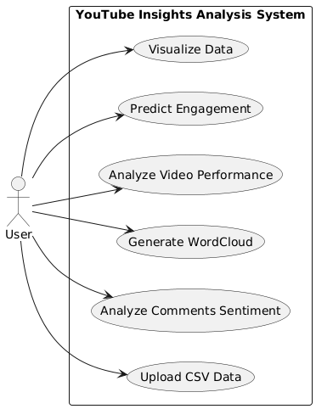
Fig 4.1.1: Use-Case Diagram

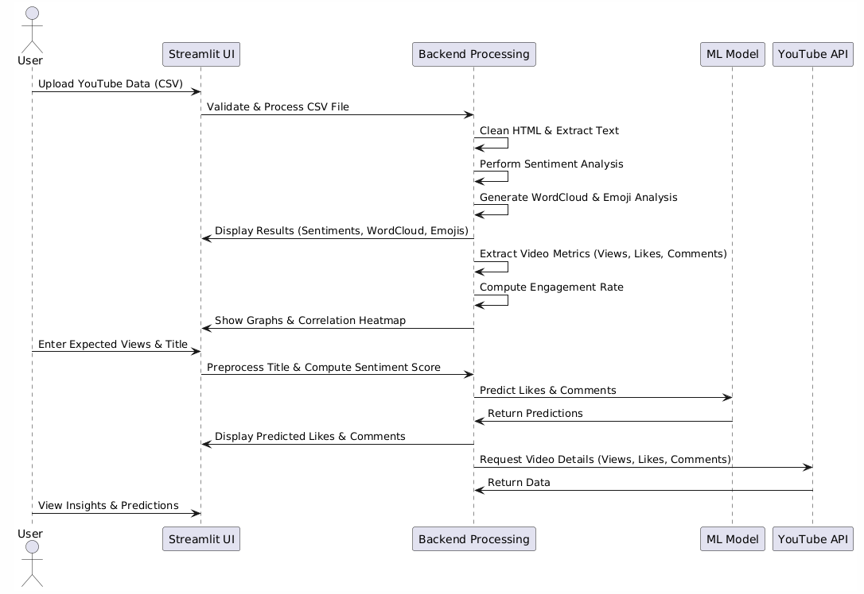
Data Flow Diagram:

Fig 4.1.2: Sequence Diagram

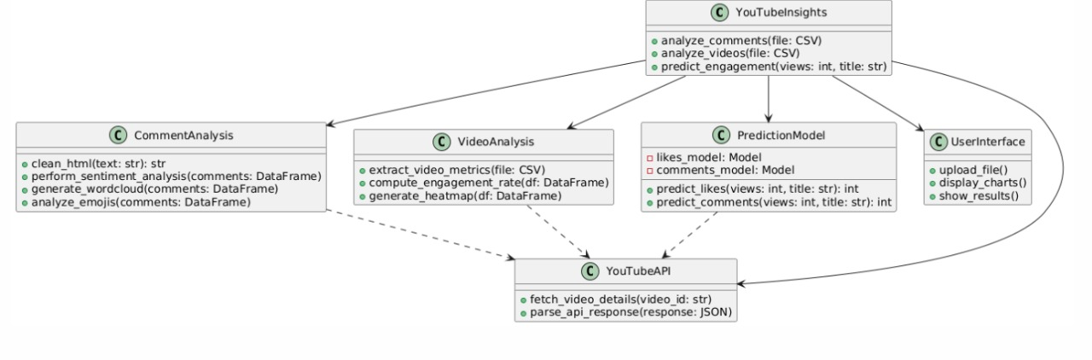

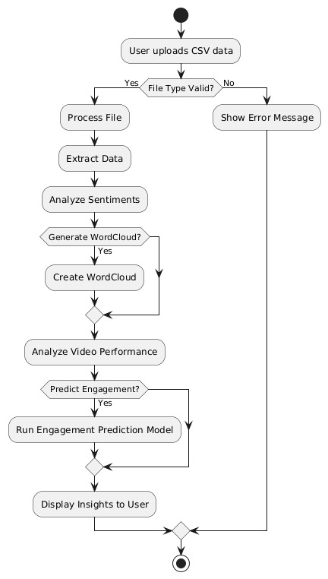
Fig 4.1.3: Class Diagram
Fig 4.1.4: Activity Diagram

CHAPTER -5 CODE

  - Source Code:

analysis.py

import streamlit as st
import pandas as pd
import seaborn as sns
import matplotlib.pyplot as plt
from textblob import TextBlob
from wordcloud import WordCloud, STOPWORDS
import emoji
from collections import Counter
import plotly.express as px
from bs4 import BeautifulSoup
import joblib # Import joblib to load model

# Function to clean HTML and preserve YouTube links
def clean_html(text):
soup = BeautifulSoup(text, "html.parser")
for a_tag in soup.find_all("a"): # Find all links
href = a_tag.get("href", "") # Extract href link
if href:
a_tag.replace_with(f"{a_tag.text} ({href})") # Replace with visible text + URL
return soup.get_text()

# Function for Comments Analysis
def analyze_comments(comments_file):
comments = pd.read_csv(comments_file)
comments.dropna(inplace=True)

# Clean HTML in comments
comments['Comment'] = comments['Comment'].apply(lambda x: clean_html(x) if isinstance(x, str) else x)

# Sentiment Analysis
comments['polarity'] = [TextBlob(comment).sentiment.polarity if isinstance(comment, str) else 0 for comment in comments['Comment']]

analysis_type = st.sidebar.radio("Choose Analysis", ["Sentiment Analysis", "WordCloud", "Emoji Analysis"])

if analysis_type == "Sentiment Analysis":
sentiment_choice = st.radio("Select Sentiment Type", ["Overall", "Positive", "Negative", "Neutral"])

if sentiment_choice == "Overall":
st.subheader("Sentiment Score Distribution")
fig = px.histogram(comments, x='polarity', nbins=50, title="Sentiment Score Distribution", color_discrete_sequence=['#FF6361'])
st.plotly_chart(fig, use_container_width=True)

elif sentiment_choice == "Positive":

positive_comments = comments[comments['polarity'] > 0]
st.write(f"### Positive Comments (Total: {len(positive_comments)})")
st.dataframe(positive_comments[['Comment', 'polarity']].head(10))

elif sentiment_choice == "Negative":
negative_comments = comments[comments['polarity'] < 0]
st.write(f"### Negative Comments (Total: {len(negative_comments)})")
st.dataframe(negative_comments[['Comment', 'polarity']].head(10))

elif sentiment_choice == "Neutral":
neutral_comments = comments[comments['polarity'] == 0]
st.write(f"### Neutral Comments (Total: {len(neutral_comments)})")
st.dataframe(neutral_comments[['Comment', 'polarity']].head(10))

elif analysis_type == "WordCloud":
wordcloud_type = st.radio("Choose Sentiment for WordCloud", ["Positive", "Negative"])
st.subheader(f"WordCloud for {wordcloud_type} Comments")

wordcloud_text = ' '.join(comments[comments['polarity'] > 0]['Comment']) if wordcloud_type == "Positive" else ' '.join(comments[comments['polarity'] < 0]['Comment'])

wordcloud = WordCloud(stopwords=set(STOPWORDS), background_color="white").generate(wordcloud_text)

fig, ax = plt.subplots(figsize=(5, 3))
ax.imshow(wordcloud, interpolation='bilinear')
ax.axis("off")
st.pyplot(fig)

elif analysis_type == "Emoji Analysis":
st.subheader("Emoji Frequency Analysis")

all_emojis_list = [char for comment in comments['Comment'].dropna() for char in comment if char in emoji.EMOJI_DATA]
emoji_counts = Counter(all_emojis_list).most_common(10)

if emoji_counts:
emojis, freqs = zip(*emoji_counts)
fig = px.bar(x=emojis, y=freqs, title="Top 10 Emojis Used", labels={'x': 'Emoji', 'y': 'Frequency'}, color_discrete_sequence=['#58508D'])
st.plotly_chart(fig, use_container_width=True)
else:
st.write("No emojis found in comments.")

# Function for Videos Performance Analysis
def analyze_videos(videos_file):
df = pd.read_csv(videos_file)
df.columns = df.columns.str.strip().str.lower()

st.subheader("🎥 YouTube Videos Performance Analysis")

fig_size = (5, 2)

col1, col2 = st.columns(2)

with col1:
st.write("### Views vs. Likes")
fig, ax = plt.subplots(figsize=fig_size)
sns.scatterplot(x=df["views"], y=df["likes"], ax=ax)
ax.set_title("Views vs. Likes")
st.pyplot(fig)

with col2:
st.write("### Views vs. Comments")
fig, ax = plt.subplots(figsize=fig_size)
sns.scatterplot(x=df["views"], y=df["comments"], ax=ax)
ax.set_title("Views vs. Comments")
st.pyplot(fig)

st.write("### Correlation Heatmap")
fig, ax = plt.subplots(figsize=fig_size)
sns.heatmap(df[["views", "likes", "comments"]].corr(), annot=True, cmap="coolwarm", ax=ax)
st.pyplot(fig)

df["engagement_rate"] = (df["likes"] + df["comments"]) / df["views"] * 100

st.write("### Engagement Rate Distribution")
fig, ax = plt.subplots(figsize=fig_size)
sns.histplot(df["engagement_rate"], bins=20, kde=True, ax=ax)
st.pyplot(fig)

top_videos = df.sort_values("engagement_rate", ascending=False).head(10)
st.write("### Top 10 Engaging Videos")
st.dataframe(top_videos[["title", "views", "likes", "comments", "engagement_rate"]])
# Function to predict Likes & Comments for a new video
import numpy as np
likes_model = joblib.load("likes_prediction_model.pkl")
comments_model = joblib.load("comments_prediction_model.pkl")

# Function to predict Likes & Comments for a new video
def predict_engagement(views, title):
if not likes_model or not comments_model:
st.error("⚠️ Prediction models not found.")
return 0, 0

title_length = len(title)
sentiment_score = TextBlob(title).sentiment.polarity

# Convert to DataFrame with correct column names as used in training
features = pd.DataFrame([[views, title_length, sentiment_score]],
columns=['Views', 'Title_Length', 'Sentiment_Score']) # Updated names

predicted_likes = round(likes_model.predict(features)[0])
predicted_comments = round(comments_model.predict(features)[0])

return predicted_likes, predicted_comments

train_model.py
import pandas as pd
import numpy as np
import joblib
from sklearn.model_selection import train_test_split
from sklearn.ensemble import RandomForestRegressor
from sklearn.pipeline import Pipeline
from sklearn.preprocessing import StandardScaler
from textblob import TextBlob

# Load the dataset
df = pd.read_csv(r"C:\Users\ganes\Documents\UCYC6Vcczj8v-Y5OgpEJTFBw_videos.xls.csv")

# Feature Engineering: Extract new features
df['Title_Length'] = df['Title'].apply(lambda x: len(str(x)))
df['Sentiment_Score'] = df['Title'].apply(lambda x: TextBlob(str(x)).sentiment.polarity)

# Engagement Metrics (Likes per View, Comments per View)
df['Likes_Per_View'] = df['Likes'] / df['Views']
df['Comments_Per_View'] =

df['Comments'] / df['Views']

# Drop missing values (important for ratio-based columns)
df = df.dropna()

# Features and Targets
X = df[['Views', 'Title_Length', 'Sentiment_Score']]
y_likes = df['Likes']
y_comments = df['Comments']

# Train-test split
X_train, X_test, y_likes_train, y_likes_test = train_test_split(X, y_likes, test_size=0.2, random_state=42)
X_train, X_test, y_comments_train, y_comments_test = train_test_split(X, y_comments, test_size=0.2, random_state=42)

# Define ML Pipelines
likes_model = Pipeline([
('scaler', StandardScaler()),
('regressor', RandomForestRegressor(n_estimators=100, random_state=42))
])

comments_model = Pipeline([
('scaler', StandardScaler()),
('regressor', RandomForestRegressor(n_estimators=100, random_state=42))
])

# Train the models
likes_model.fit(X_train, y_likes_train)
comments_model.fit(X_train, y_comments_train)

# Save the trained models
joblib.dump(likes_model, 'likes_prediction_model.pkl')
joblib.dump(comments_model, 'comments_prediction_model.pkl')

print("✅ Model training complete! Saved models: likes_prediction_model.pkl, comments_prediction_model.pkl")

predict.py
import joblib
import numpy as np
from textblob import TextBlob

# Load trained models
likes_model = joblib.load("likes_prediction_model.pkl")
comments_model = joblib.load("comments_prediction_model.pkl")

def predict_engagement(views, title):
"""Predicts likes and comments for a new video based on views and title."""

title_length = len(title)
sentiment_score =

TextBlob(title).sentiment.polarity

# Prepare input features
features = np.array([[views, title_length, sentiment_score]])

# Predict likes and comments
predicted_likes = likes_model.predict(features)[0]
predicted_comments = comments_model.predict(features)[0]

return round(predicted_likes), round(predicted_comments)

# Example Usage
if __name__ == "__main__":
views = float(input("Enter expected views for the new video: "))
title = input("Enter the video title: ")

likes, comments = predict_engagement(views, title)

print(f"\n📊 **Predicted Engagement:**")
print(f"👍 Predicted Likes: {likes}")
print(f"💬 Predicted Comments: {comments}")

app.py

import streamlit as st
import pandas as pd
import requests
from PIL import Image
from io import BytesIO
from analysis import analyze_comments, analyze_videos, predict_engagement

# Set Page Config
st.set_page_config(page_title="YouTube Analysis", layout="wide")

# Sidebar Navigation
st.sidebar.title("📌 Navigation")
section = st.sidebar.radio("Go to", ["Upload & Overview", "Comments Analysis", "Videos Performance", "Predict Engagement"])

# Title
st.title("📊 YouTube Insights Analysis")

# Load and Display Image
image_url = "https://www.kindpng.com/picc/m/432-4328812_youtube-analytics-you-tube-logo-hd-png-download.png"
try:
response = requests.get(image_url, timeout=5)
if response.status_code == 200:

image = Image.open(BytesIO(response.content))
st.image(image, use_container_width=False)
except requests.exceptions.RequestException:
st.warning("⚠️ Failed to load image. Please check your internet connection.")

# Sidebar for Uploads
st.sidebar.subheader("📤 Upload Data")
comments_file = st.sidebar.file_uploader("Upload a CSV file for Comments Analysis", type=["csv"])
videos_file = st.sidebar.file_uploader("Upload a CSV file for Videos Performance Analysis", type=["csv"])

# Process Sections
if section == "Comments Analysis":
if comments_file:
analyze_comments(comments_file)
else:
st.warning("⚠️ Please upload a CSV file to analyze comments.")

elif section == "Videos Performance":

if videos_file:
analyze_videos(videos_file)
else:
st.warning("⚠️ Please upload a CSV file to analyze video performance.")

elif section == "Predict Engagement":
st.subheader("📈 Predict Likes & Comments for a New Video")
expected_views = st.number_input("Enter Expected Views", min_value=0, step=1000)
video_title = st.text_input("Enter the Video Title")

if st.button("Predict"):
if video_title.strip():
try:
predicted_likes, predicted_comments = predict_engagement(expected_views, video_title)
st.success(f"📌 Predicted Likes: {predicted_likes}")
st.success(f"💬 Predicted Comments: {predicted_comments}")
except Exception as e:
st.error(f"An error occurred: {e}")
else:
st.warning("⚠️ Please enter a video title!")

Screenshot of Application:

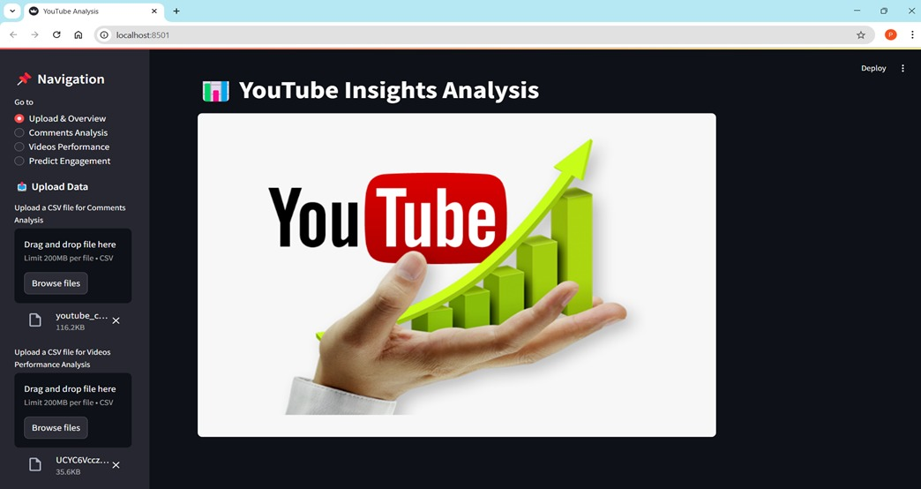
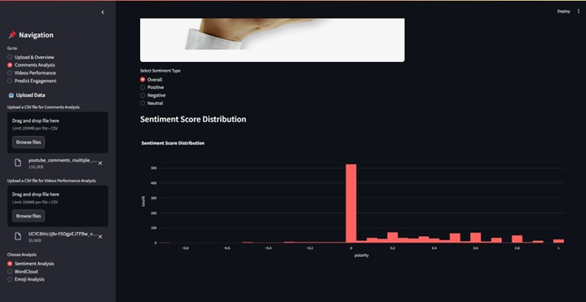
Fig 5.2.1: Upload and Overview

Fig 5.2.2: Comments analysis

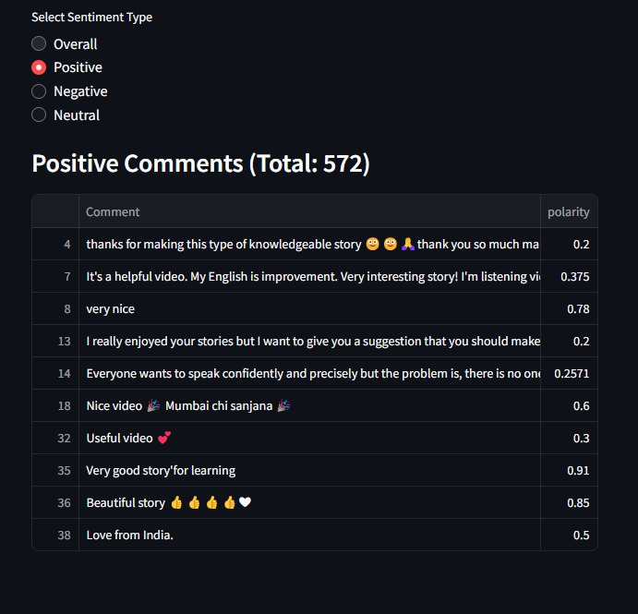

Fig 5.2.3: Sentiment Types
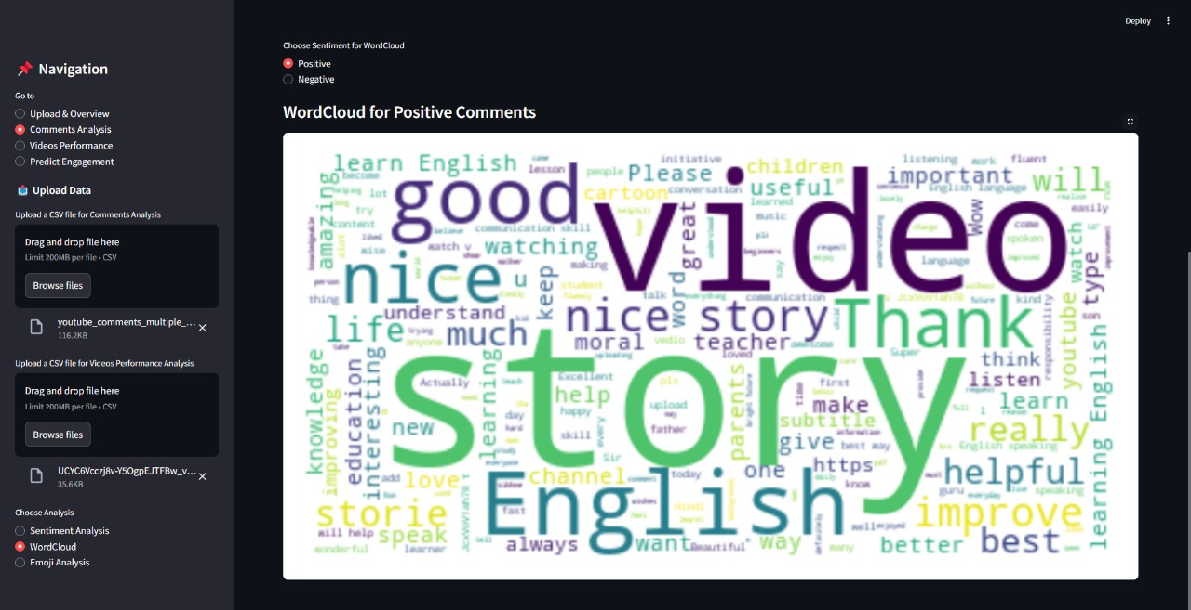

Fig 5.2.4: Positive Sentiment

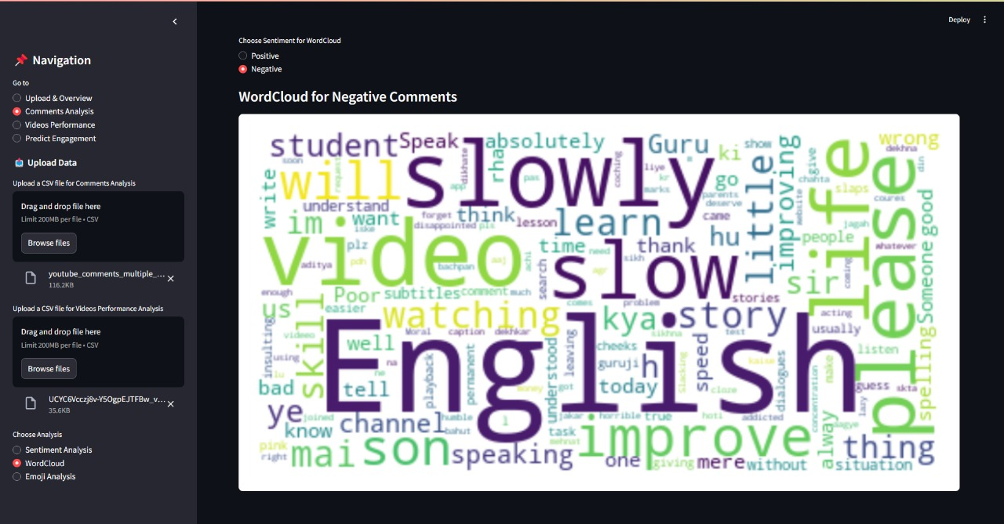

fig 5.2.4 Predict page

Fig 5.2.5: Negative Sentiment
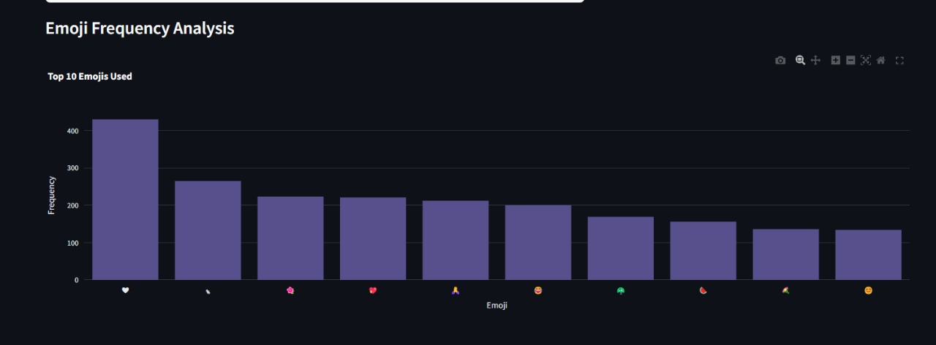

Fig 5.2.6: Emoji Frequency Analysis

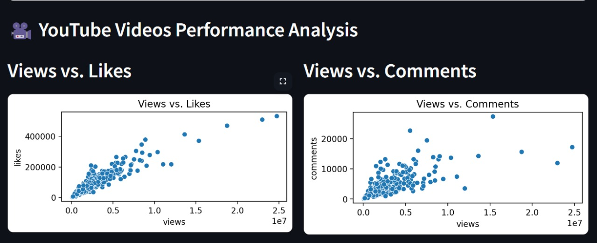

Fig 5.2.7: Performance Analysis

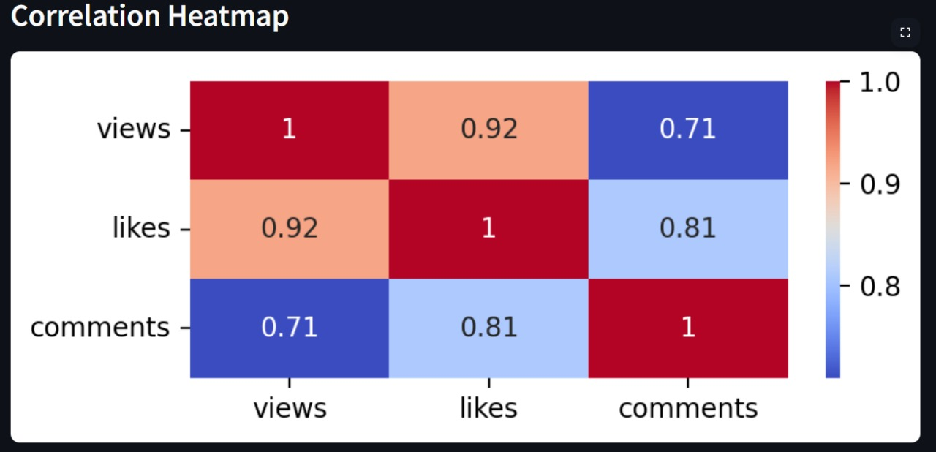

Fig 5.2.8: Heatmap

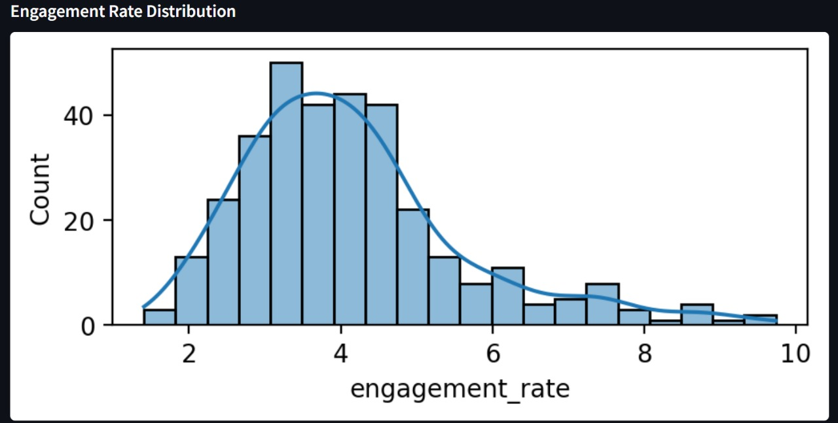

Fig 5.2.9: Rate Distribution

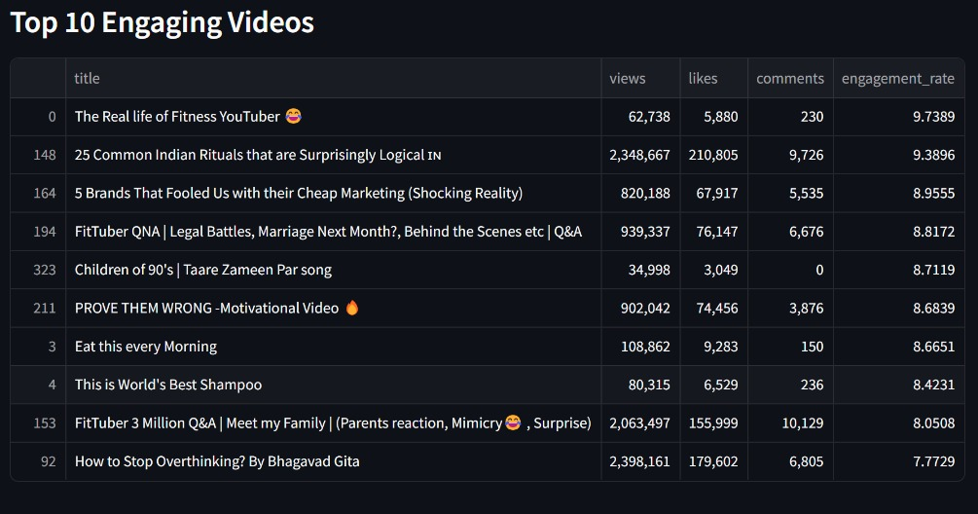

Fig 5.2.10: Top 10 Videos

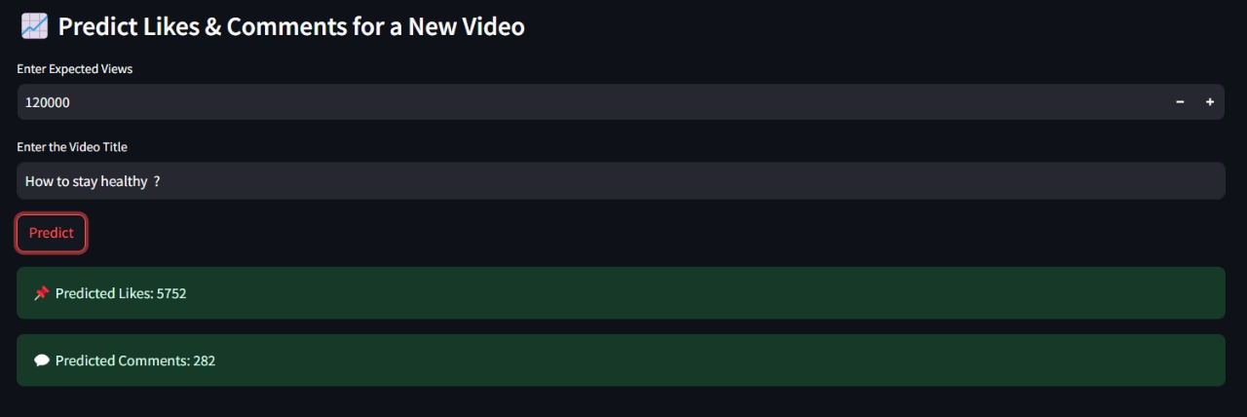

Fig 5.2.11: Prediction for new Video

CHAPTER – 6
RESULTS & CONCLUSION

6.1 Results

Real-Time Performance Monitoring:
Successfully retrieved and visualized real-time YouTube video metrics such as views, likes, comments, and upload trends using the YouTube Data API.

Audience Sentiment Analysis:
Implemented sentiment analysis on comments to classify audience feedback as positive, negative, or neutral, helping creators gauge audience mood and response.

Predictive Analytics:
Developed machine learning models to predict future likes, comments, and engagement metrics based on historical data, enabling proactive content planning.

Word Cloud Insights:
Generated dynamic word clouds to highlight commonly used terms in user comments, helping identify trending topics and viewer interests.

User-Friendly Streamlit Interface:
Built an intuitive and interactive web interface using Streamlit that allows users to explore analytics without technical knowledge, making the tool widely accessible.

Improved Content Strategy Insights:
Provided actionable insights such as best posting times, most engaging topics, and sentiment-driven feedback loops to support content strategy optimization.

Scalability & Adaptability:
The system is designed to support different channels and video types, making it scalable for individual creators, agencies, and businesses.

6.2 Conclusion:

The project successfully demonstrates the power of integrating the YouTube Data API with machine learning and sentiment analysis to derive meaningful insights from video performance and audience behavior. By transforming raw engagement metrics into interactive visual dashboards, the system empowers content creators and marketers to monitor, evaluate, and optimize their strategies in real time. The incorporation of predictive models adds a forward-looking dimension, allowing users to anticipate future engagement trends and adjust content accordingly.

Through sentiment analysis of viewer comments, creators gain a deeper understanding of audience emotions, providing a human layer to otherwise numerical data. This highlights the value of data-driven decision-making in improving content targeting, enhancing viewer satisfaction, and driving channel growth. Additionally, the user-friendly, no-code Streamlit interface ensures accessibility for individuals with limited technical backgrounds, making advanced analytics more inclusive.

Features such as word cloud generation offer visual insights into trending themes and audience preferences, enabling content to stay relevant and engaging. The platform is built with scalability and flexibility in mind, making it suitable for a wide range of users, from independent creators to marketing teams and educational influencers. Ultimately, this project reinforces the essential role of AI-powered analytics in today’s digital content landscape, giving creators a strategic edge. It also lays the groundwork for future improvements, such as automated content recommendations, topic clustering, and personalized viewer engagement strategies.

Future Scope:

Integration with Multiple Platforms:
While this project currently focuses on YouTube, the architecture can be extended to support other platforms like Instagram, TikTok, Facebook, and Twitter, enabling multi-platform content performance analysis.

Advanced Recommendation Engine:
Future iterations can include AI-powered content recommendation systems that suggest optimal video topics, titles, and tags based on trending data, audience preferences, and historical performance.

Real-Time Notification System:
Implementing real-time alerts for sudden spikes or drops in views, likes, or sentiment can help creators respond promptly to audience engagement or negative feedback.

Automated Report Generation:
The system can be enhanced to automatically generate detailed performance reports (daily/weekly/monthly) in PDF or Excel formats for sharing with teams or clients.

Deep Emotion Analysis:
Beyond basic sentiment classification, future upgrades can involve emotion detection (joy, anger, surprise, etc.) from comments to provide even more nuanced audience insights.

Voice & Video-Based Sentiment:
Expanding analysis to include voice tone (from live streams) and facial expressions (from video thumbnails or reactions) can offer multimodal sentiment insights.

Content Performance Benchmarking:
Adding features to compare a creator’s performance against industry averages or competitor channels can help users identify areas of improvement and growth.

User Personalization & Dashboards:
Future updates may include customizable dashboards tailored to individual creator goals, allowing users to focus on metrics most relevant to them.

AI Chatbot for Insights:
Integration of an AI chatbot to provide on-demand insights and suggestions based on current analytics could further enhance usability and engagement.

Mobile App Version:
To increase accessibility, a mobile app version of the system can be developed, allowing users to track analytics and receive updates on the go.

References:

- S. Hutto and E. Gilbert, “VADER: A Parsimonious Rulebased Model for Sentiment Analysis of Social Media Text,” Proceedings of the International AAAI Conference on Web and Social Media, vol. 8, no. 1, pp. 216–225, 2014.
- Ratnadira Widyasari; Muhammad Zuhri Catur Candra; Saiful Akbar, “Sentiment Analysis of YouTube Comments Using TextBlob,” International Conference on Data and
Software Engineering (ICoDSE), 2019. DOI:
10.1109/ICoDSE48770.2019.9092707.
- Vaibhav Hans; Parminder Singh Sethi, “Machine Learning Based Engagement Prediction in Social Media
Platforms,” International Conference on Green Computing and Internet of Things (ICGCIoT), 2015. DOI: 10.1109/ICGCIoT.2015.7380487.
- F. Pedregosa et al., “Scikit-learn: Machine Learning in Python,” Journal of Machine Learning Research, vol. 12, pp. 2825–2830, 2011.
- Streamlit Inc., “Streamlit: The fastest way to build data apps,” World Congress on Data Science Platforms, 2021. Available: https://streamlit.io/
- Google Developers, “YouTube Data API v3,” YouTube Official Documentation, 2023. Available:
https://developers.google.com/youtube/v3
- L. Breiman, “Random Forests,” Machine Learning, vol. 45, pp. 5–32, 2001.

